**FAILOVER ROUTING POLICY**

**STEP 1) CREATE HOSTED ZONE**

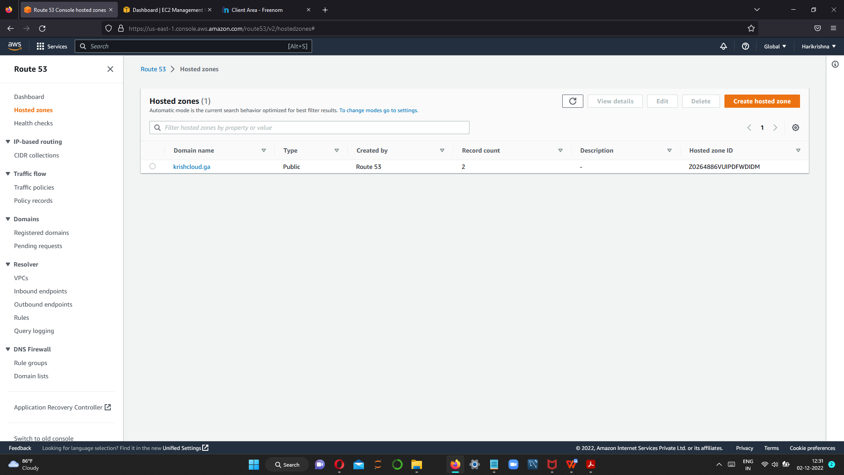

**STEP 2 COPY THE NAME SERVERS AND PASTE IT IN DOMAIN PURCHASER WEBSITE i.e freenom**

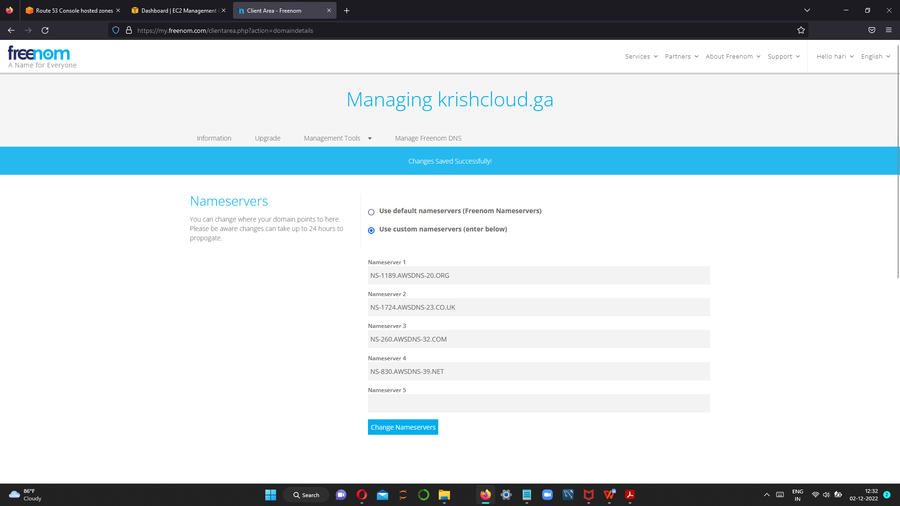

**Step 3 create two instance one in london and second one in singapore**

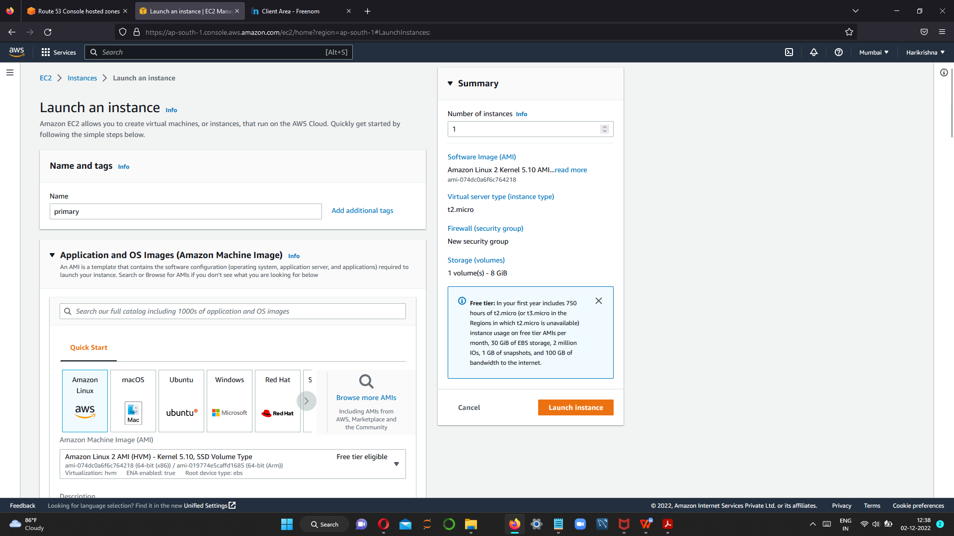

**In security group give all tcp**

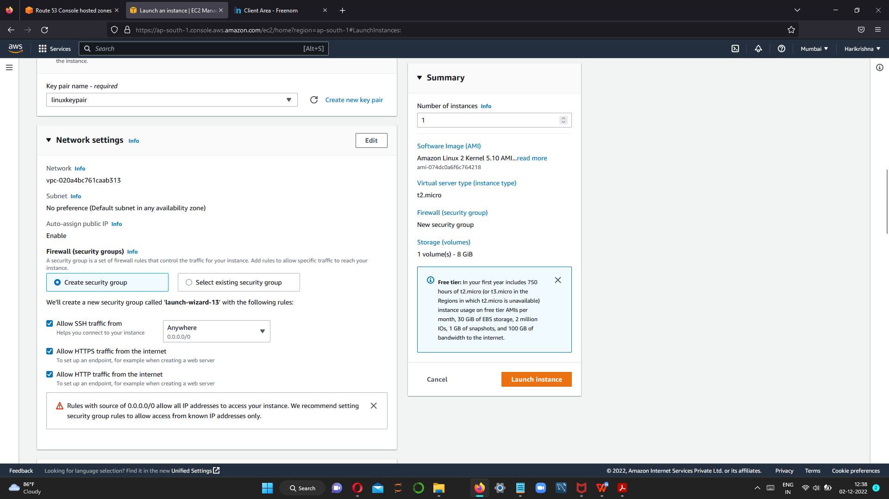

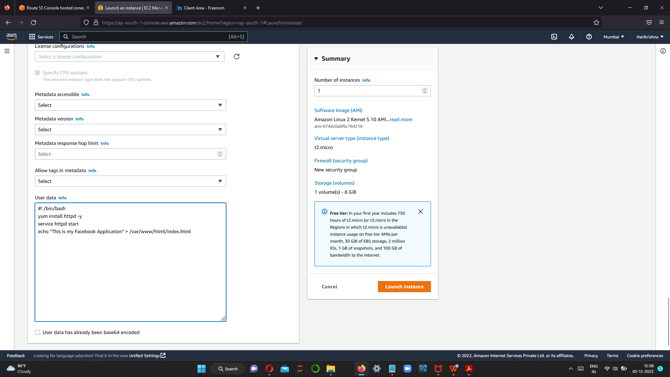

**Same procedure to create secondary instance.**

**Step 4 after creating the instances , hit the public ip in the browser.**





**Step 5 Create health record for both instance.**

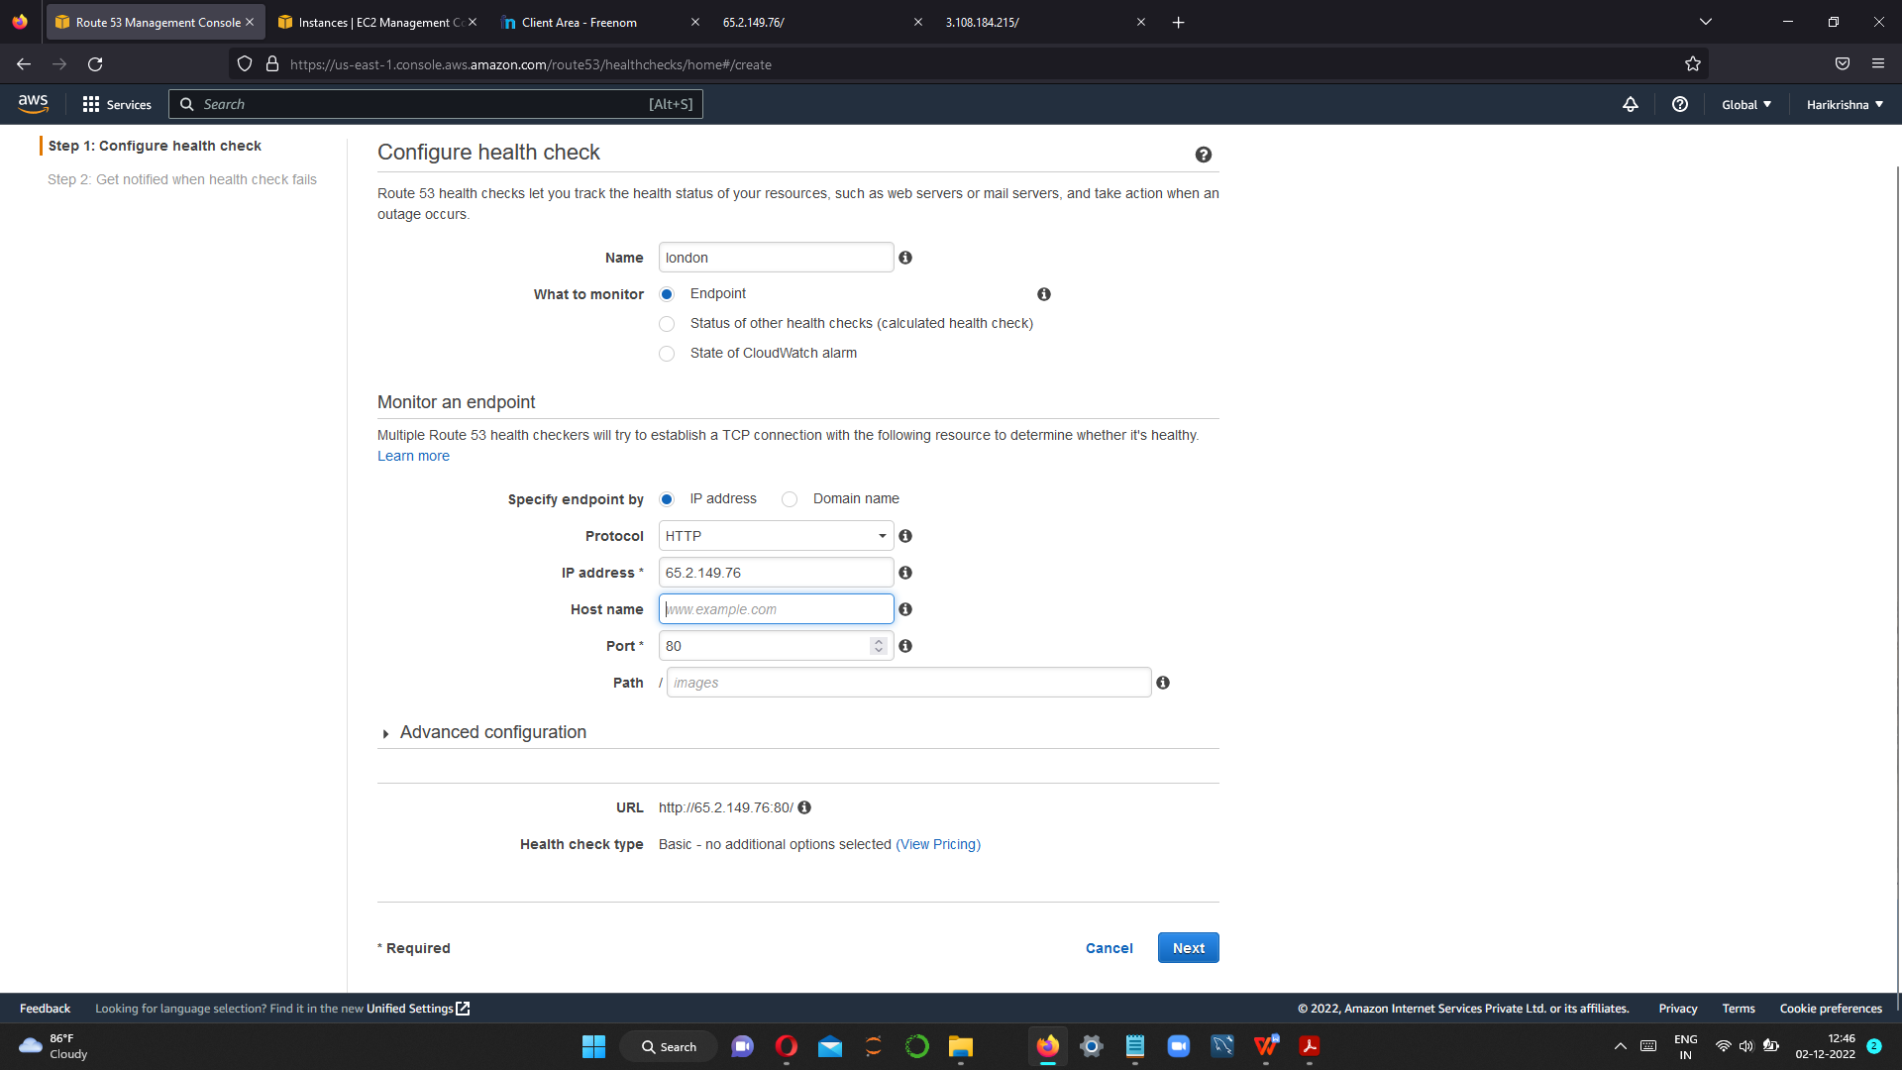

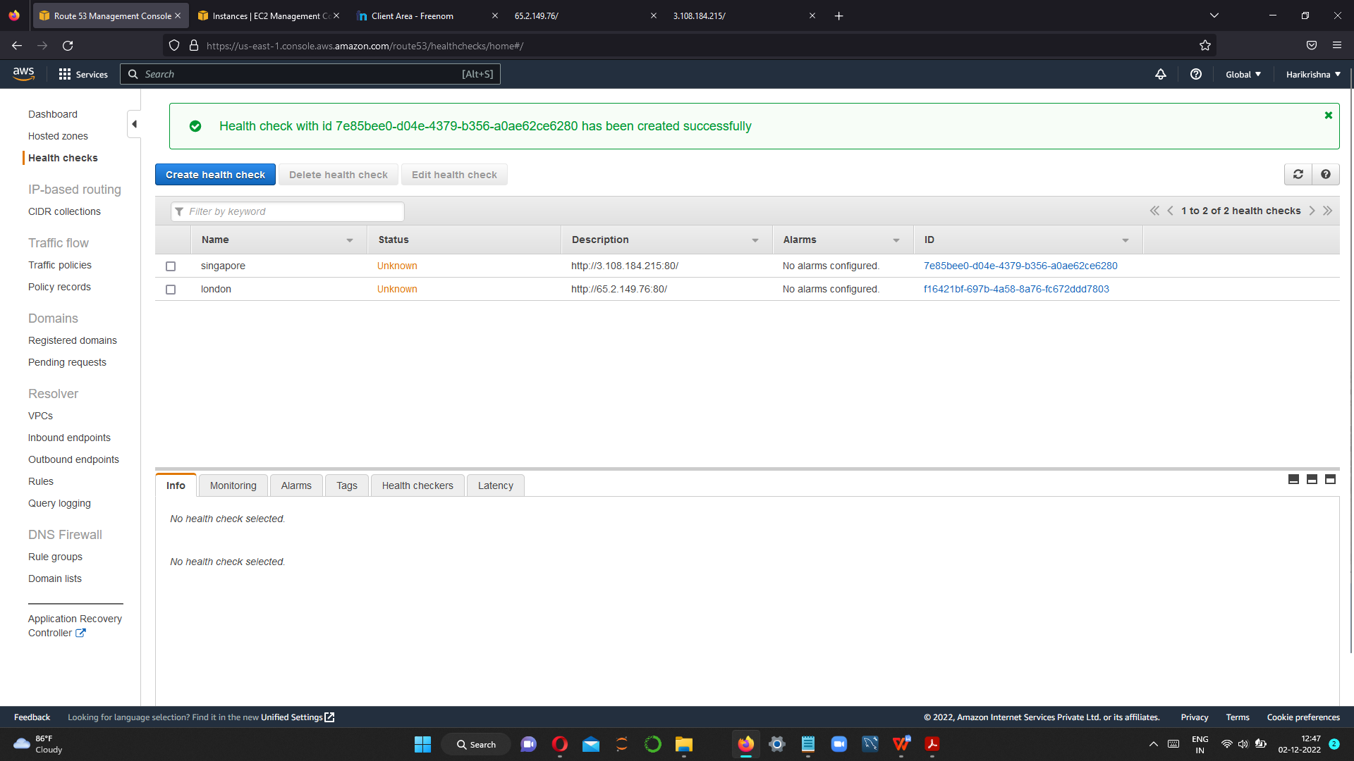

**Step 6 create record for both the instance**

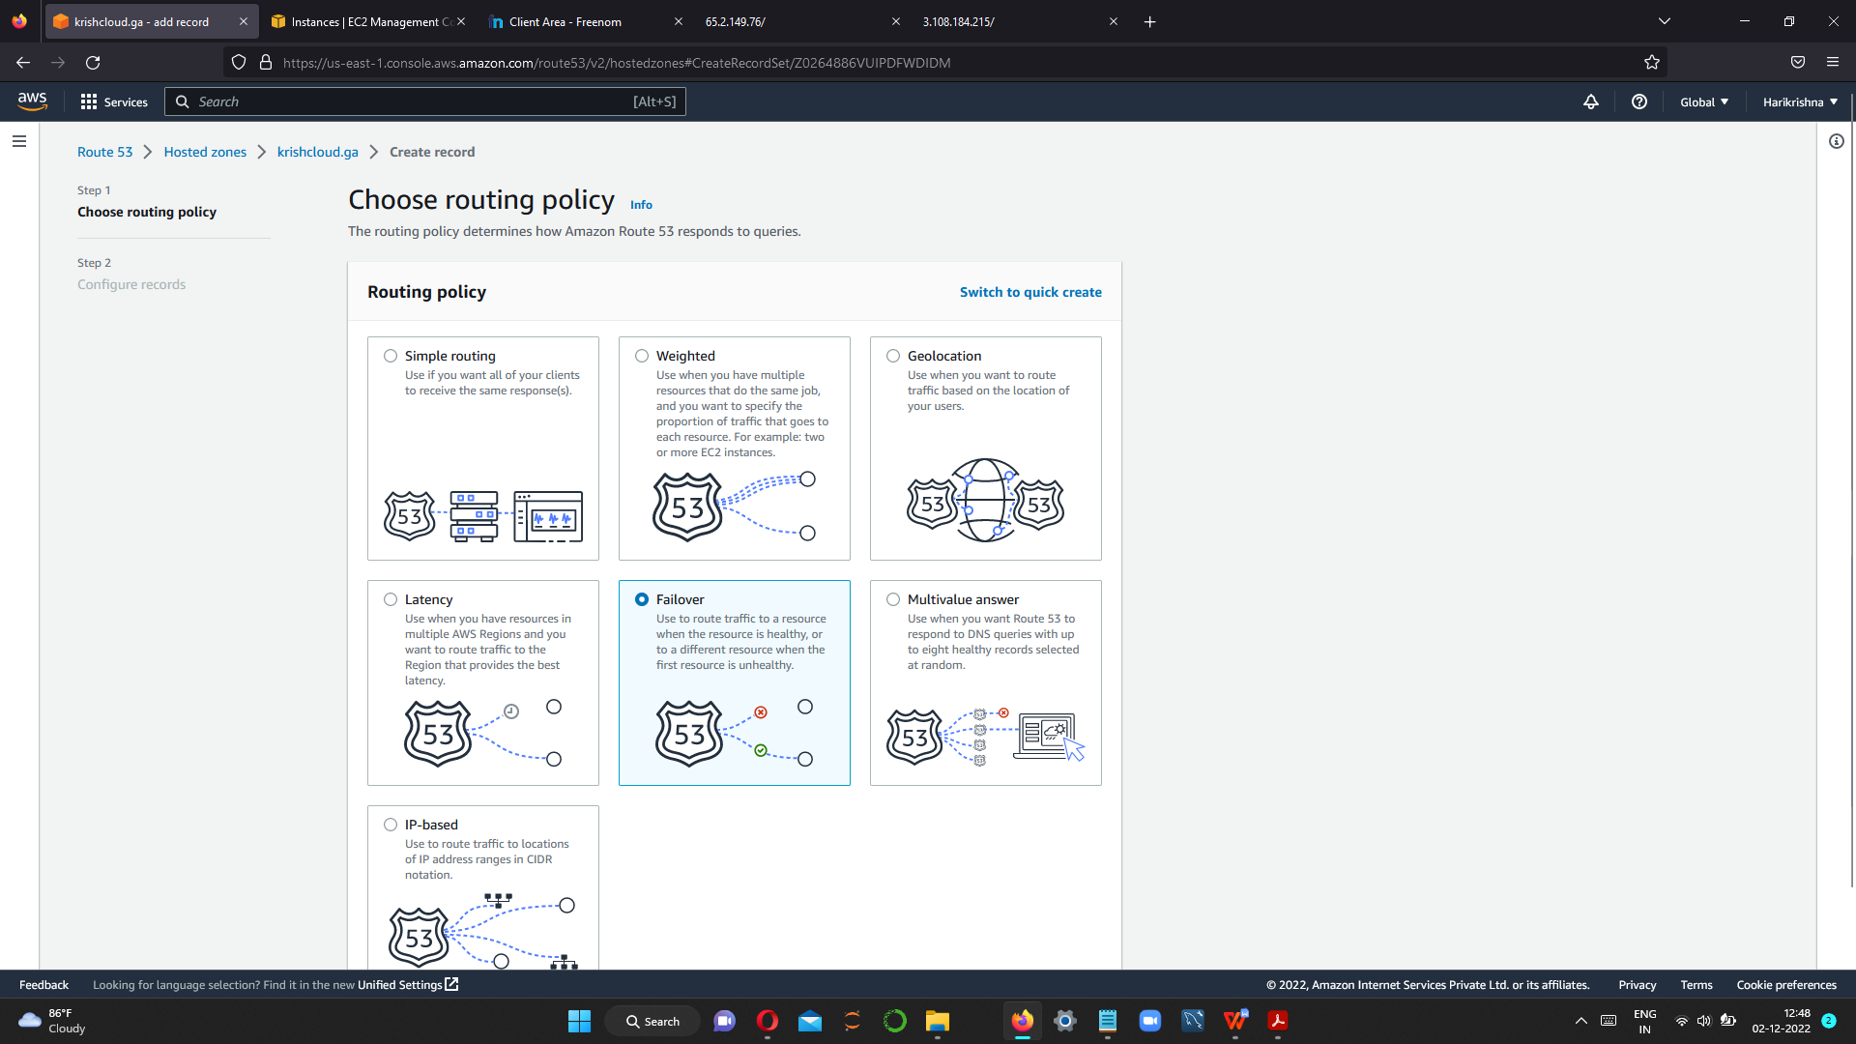

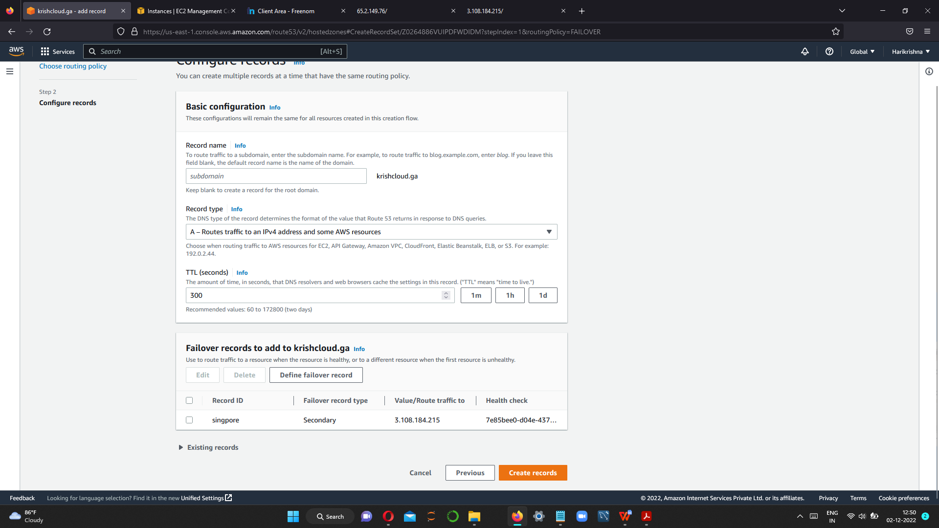

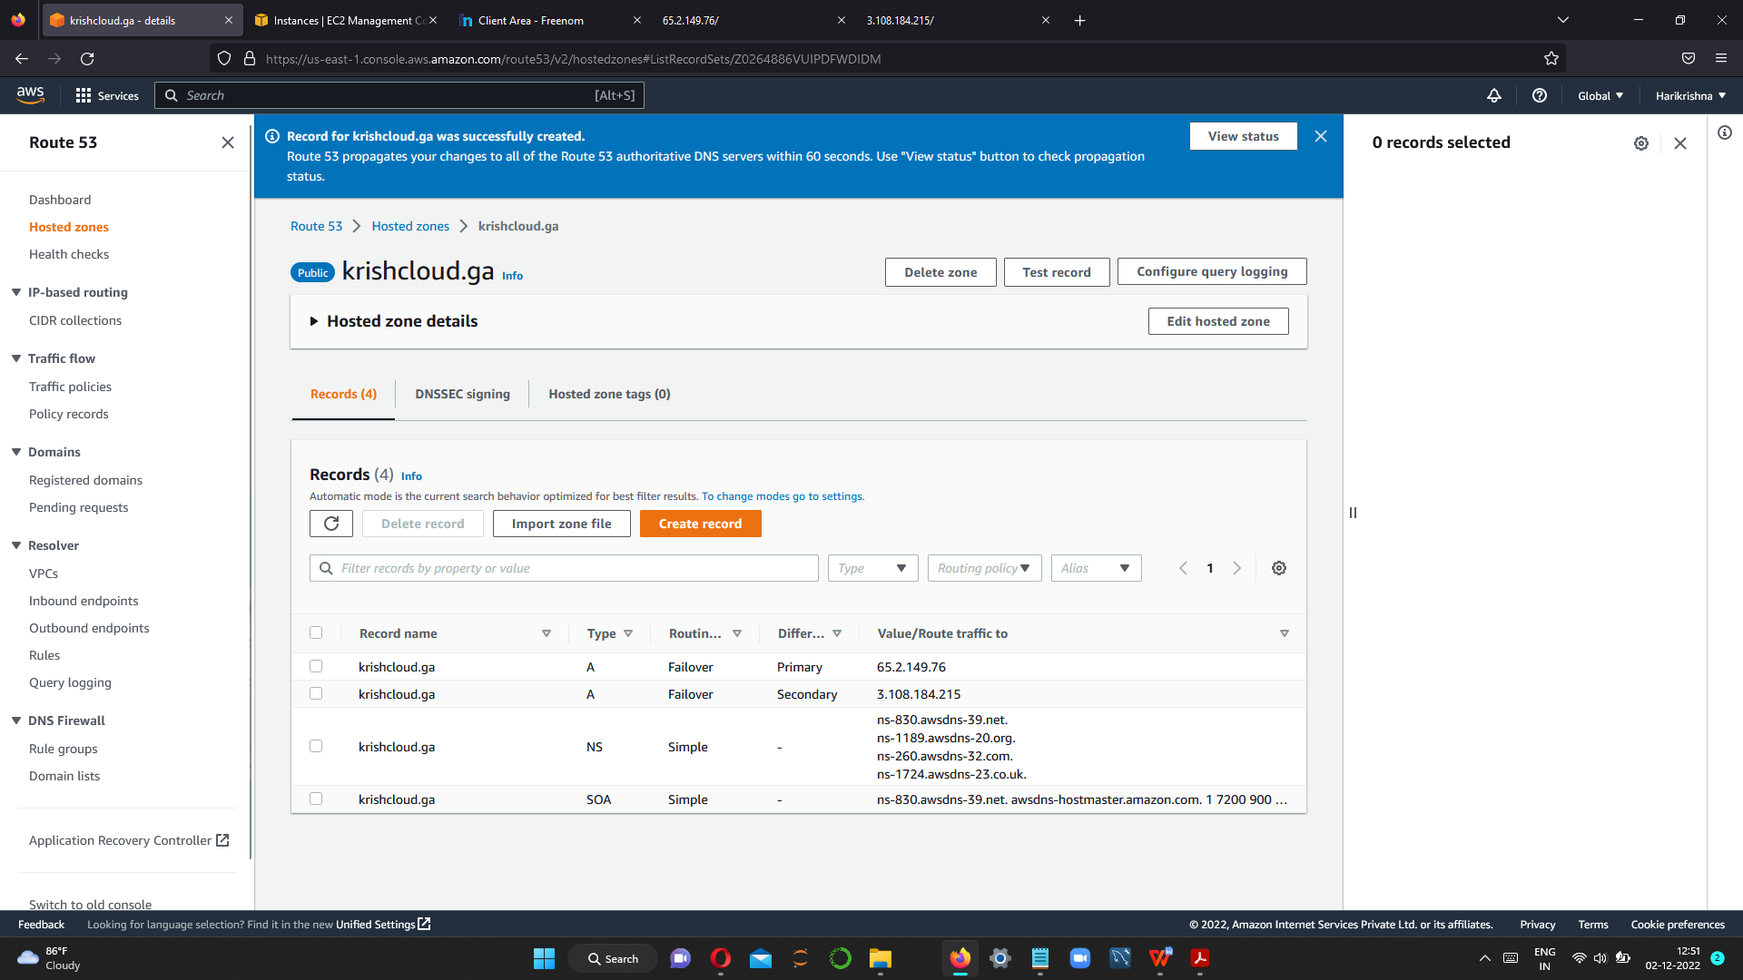

**step 7 go to browser and hit the domain name**



**Now stop the primary server**

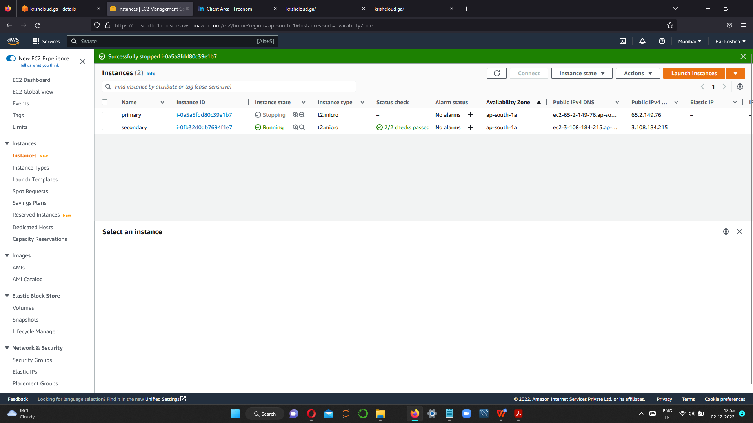

**Now Health Check is unhealthy**

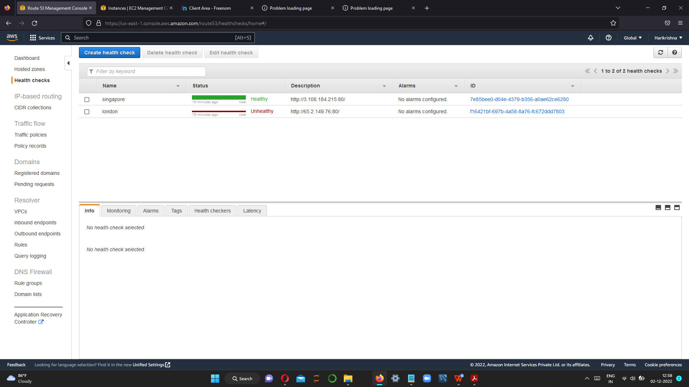

**Now secondary server is running.**



**If primary down then Secondary will become a Primary and respond to remote user – Fail over**